# Artificial intelligence Course for Everyone

### Week 1 Quiz

**TOTAL POINTS 10**

1.Question 1

Which of these terms best describes the type of AI used in today’s email spam filters, speech recognition, and other specific applications?



Artificial Narrow Intelligence (ANI)



Artificial General Intelligence (AGI)

1 point

2.Question 2

What do you call the commonly used AI technology for learning input (A) to output (B) mappings?



Reinforcement learning



Supervised learning



Artificial General Intelligence



Unsupervised learning

1 point

3.Question 3

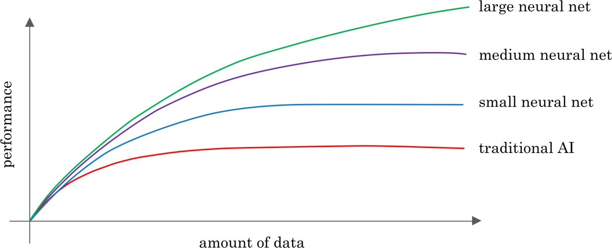

You want to use supervised learning to build a speech recognition system. The figure above suggests that in order for a neural network (deep learning) to achieve the best performance, you would ideally use: (Select all that apply)



A large dataset (of audio files and the corresponding text transcript)



A small dataset (of audio files and the corresponding text transcript)



A large neural network



A small neural network

1 point

4.Question 4

The only way to acquire data for a supervised learning algorithm is to manually label it. I.e., given the input A, to ask a human to provide B.



True



False

1 point

5.Question 5

Which of these statements regarding data acquisition do you agree with?



It doesn’t matter how data is acquired. The more data, the better.



Some types of data are more valuable than others; working with an AI team can help you figure out what data to acquire.



Only structured data is valuable; AI cannot process unstructured data.



It doesn’t help to give data to an AI team, because they can always produce whatever they need by themselves.

1 point

6.Question 6

You run a company that manufactures scooters. Which of the following are examples of unstructured data? (Select all that apply.)



The number of scooters sold per week over the past year



Pictures of your scooters



The maximum speed of each of your scooters



Audio files of the engine sound of your scooters

1 point

7.Question 7

Suppose you run a website that sells cat food. Which of these might be a good result from a Data Science project? (Select all that apply.)



A neural network that closely mimics how cats’ brains work.



Insights into how to market cat food more effectively, depending on the breed of cat.



A large dataset of images labeled as “Cat” and “Not Cat”



A slide deck presenting a plan on how to modify pricing in order to improve sales.

1 point

8.Question 8

Based on the terminology defined in Video 4, which of the following statements do you agree with? (Select all that apply.)



AI is a type of deep learning. (I.e., all AI algorithms are deep learning algorithms.)



Deep learning is a type of machine learning.  (I.e., all deep learning algorithms are machine learning algorithms.)



The terms “Machine learning” and “data science” are used almost interchangeably.



The terms “Deep learning” and “neural network” are used almost interchangeably.

1 point

9.Question 9

Which of these do AI companies do well?



Strategic data acquisition



Invest in unified data warehouses



Spot automation opportunities



All of the above

1 point

10.Question 10

Say you want to input a picture of a person’s face (A), and output whether or not they are smiling (B). Because this is a task that most humans can do in less than 1 second, supervised learning can probably learn this A-to-B mapping.



True



False

1 point

# Week 2

1.Question 1

Machine learning is an “iterative” process, meaning that an AI team often has to try many ideas before coming up with something that’s good enough, rather than have the first thing they try work.



True



False

1 point

2.Question 2

Say you want to use Machine Learning to help your sales team with automatic lead sorting. I.e., Input A (a sales prospect) and output B (whether your sales team should prioritize them). The 3 steps of the workflow, in scrambled order, are:

(i) Deploy a trained model and get data back from users

(ii) Collect data with both A and B

(iii) Train a machine learning system to input A and output B

What is the correct ordering of these steps?



(ii) (iii) (i)



(i) (iii) (ii)



(ii) (i) (iii)



(i) (ii) (iii)

1 point

3.Question 3

What are the key steps of a Data Science project?



Collect data



Analyze the data



Suggest hypothesis or actions



All of the above

1 point

4.Question 4

Machine Learning programs can help: (select all that apply)



Automate visual inspection in a manufacturing line



Automate resume screening



Automate lead sorting in sales



Customize product recommendations

1 point

5.Question 5

Unless you have a huge dataset (“Big Data”), it is generally not worth attempting machine learning or data science projects on your problem.



True



False

1 point

6.Question 6

Say you want to build an AI system to help recruiters with automated resume screening. Which of these steps might be involved in “technical diligence” process?  (Select all that apply.)



Defining an engineering timeline



Making sure you can get enough data for this project



Making sure that an AI system can meet the desired performance



Ensuring that this is valuable for your business (e.g., estimating the project ROI)

1 point

7.Question 7

Which of these statements about “business diligence” do you agree with?



Business diligence applies only if you are launching new product lines or businesses.



Business diligence can typically be completed in less than a day.



Business diligence is the process of ensuring that the envisioned AI technology is feasible.



Business diligence is the process of ensuring that the AI technology, if it is built, is valuable for your business.

1 point

8.Question 8

You want to use supervised learning for automated resume screening, as in the example above. Which of the following statements about the Training Set are true? (Select all that apply.)



It should give examples of the input A (resume) but not necessarily the desired output B (whether to move forward with a candidate).



It will be used by the AI team to train the supervised learning algorithm.



It should give examples of both the input A (resume) and the desired output B (whether to move forward with a candidate).



The Training set and Test set can be the same dataset.

1 point

9.Question 9

For your automated resume screening application, you are now providing a Test Set to the AI team. Which of the following statements about the Test Set are true? (Select all that apply.)



It should give examples of both the input A (resume) and the desired output B (whether to move forward with a candidate)



It should give examples of the input A (resume) but not necessarily the desired output B (whether to move forward with a candidate).



The Test Set should ideally be identical to the Training Set.



It will be used by the AI team to evaluate the performance of the algorithm.

1 point

10.Question 10

Which of these are reasons that it’s often unrealistic to expect an ML system to be 100% accurate?



You might not have enough data



Data can be mislabeled



Data can be ambiguous



All of the above.

1 point

## Week 3

Because smart speakers can carry out multiple functions (such as tell a joke, play music, etc.) it is an example of Artificial General Intelligence (AGI).



True



False

1 point

2.Question 2

What are the key steps to a smart speaker function?



Trigger detection -> intent recognition -> speech recognition -> command execution.



Trigger word detection -> intent recognition -> speech recognition -> command execution.



Speech recognition → Trigger word detection -> intent recognition -> command execution.



Trigger word detection -> speech recognition -> intent recognition -> command execution.

1 point

3.Question 3

Consider this system for building a self-driving car:

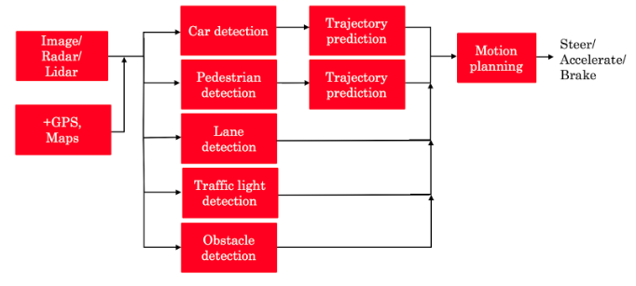

The component for pedestrian detection is usually built using:



Reinforcement learning



Supervised learning



GANs



A motion planning algorithm

1 point

Suppose you are building a trigger word detection system, and want to hire someone to build a system to map from Inputs A (audio clip) to Outputs B (whether the trigger word was said), using existing AI technology. Out of the list below, which of the following hires would be most suitable for writing this software?



AI Product Manager



Machine learning researcher



Machine learning engineer



Data engineer

1 point

5.Question 5

What is the first step in the AI Transformation Playbook for helping your company become good at AI?



Build an in-house AI team



Provide broad AI training



Execute pilot projects to gain momentum



Develop an AI strategy

Of the following options, which is the most important trait of your first pilot project?



Succeed and show traction within 6-10 months



Drive extremely high value for the business



Be executed by an in-house team



None of the above

1 point

7.Question 7

Say you are building a smart speaker, and want to accumulate data for your product through having many users. Which of these represents the “Virtuous circle of AI” for this product?



(A)

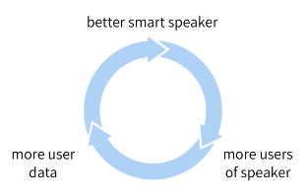



(B)

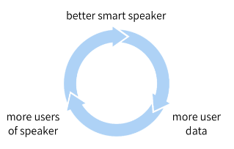



(C)

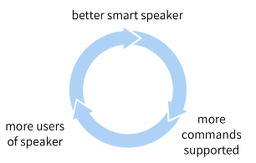



(D)

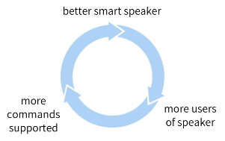

1 point

8.Question 8

Why is developing an AI strategy NOT the first step in the AI Transformation Playbook?



When transforming a company into an AI company, one does not need a strategy, therefore it can’t be the first step.



Without having some practical AI experience and knowing what it feels like to build an AI project, a company usually does not know enough to formulate a sound strategy.



The strategy should be to use the Virtuous Circle of AI, which comes after building a product.



There is no reason. Developing an AI strategy IS the first step in the AI Transformation Playbook.

1 point

9.Question 9

According to the AI Transformation Playbook, broad AI training needs to be provided not only to engineers, but also to executives/senior business leaders and to leaders of divisions working on AI projects.



True



False

1 point

10.Question 10

Which of the following are AI pitfalls to avoid? (Select all that apply)



Expecting AI to solve everything



Expecting traditional planning processes to apply without changes



Expecting AI based projects to work the first time



Pairing engineering talent with business talent to identify feasible and valuable projects.

1 point